37.43: a) 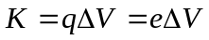
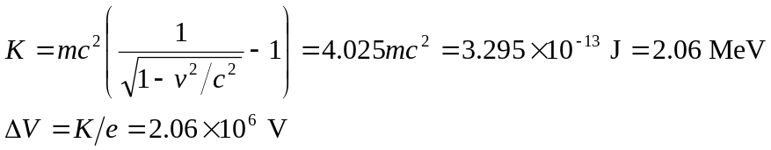
b) From part (a), 